2023-2024  SCHOOL CALENDAR  (as of 6/15/23) | 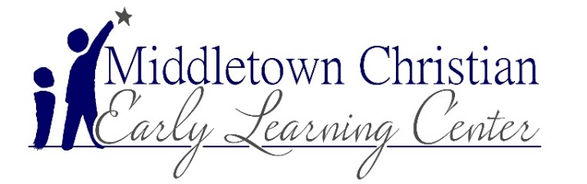  a

AUGUST 2023  14,15 ELC CLOSED for Teacher In-Service  15 Meet & Greet 5:00-8:00 for all Families  11 Last Day of Summer Program  16 First Day of Preschool  16 LIONS class First Day  SEPTEMBER 2023  4 ELC CLOSED for Labor Day  6,7 Fall Picture Days w/Little Rascals Photography  15 Class T Shirt Day  OCTOBER 2023  12-13 SCHOOL AGE holiday camp (MCS closed)  12-13 No Lions class (MCS closed)  20 Pumpkin Decorating Entries Due  20 Class T Shirt Day  31 Dress Up Day—no scary costumes  TBA Fire Truck Visit  NOVEMBER 2023  2 SCHOOL AGE early dismissal camp  3 SCHOOL AGE holiday camp (MCS closed)  3 No Lions class (MCS closed)  6,7,9 Parent/Teacher Conferences  13-28 3’s/4’s Christmas Program Practice  17 Support Your Team Day  20-22 SCHOOL AGE holiday camp (MCS closed)  20-24 NO Lions class (MCS closed)  23-24 ELC CLOSED for Thanksgiving  28 ELC Preschool Program @ GBC auditorium 7PM  DECEMBER 2023  TBA Christmas Shoppe-4’s classes  8 Pajama Day  15 Class T Shirt Day  20-29 SCHOOL AGE holiday camp (no Lions class)  25, 26 ELC CLOSED for Christmas  27-29 SCHOOL AGE holiday camp  www.ELC.mcseagles.net | JANUARY 2024  1 ELC CLOSED for New Year’s Day  2-3 SCHOOL AGE holiday camp (no Lions class)  12 SCHOOL AGE holiday camp (no Lions class)  15 MLK Day –ELC CLOSED for Teacher In-Service  19 Class T Shirt Day  TBA Kindergarten Experience (4’s classes)  FEBRUARY 2024  4 ELC Open House (New Families Only)  13,14 Valentine Parties  16 Class T Shirt Day  19 SCHOOL AGE holiday camp (MCS closed)  19 No Lions class (MCS closed)  19 Butter Braid Fundraiser begins (till March 10)  MARCH 2024  11,12,14 Parent/Teacher Conferences  6-7 Spring Photos Including Cap & Gown Pictures  7 SCHOOL AGE early dismissal camp  8 SCHOOL AGE holiday camp (MCS closed)  8 No Lions class (MCS closed)  15 Class T Shirt Day  29 ELC CLOSED for Good Friday  TBA Dentist visit  APRIL 2024  1-5 SCHOOL AGE Spring Break Camp (MCS closed)  1-5 No Lions class (SPRING BREAK)  19 Class T Shirt Day  TBA Police/K9 Dog visit  MAY 2024  1-19 K4 Graduation Practice  19 Class T Shirt Day  20 ELC K4 Graduation 7 p.m.@ GBC  21 Last Day of Classes for MCS K’s  21 Holiday Camp for MCS K’s  22 Last Day of Classes for 22-23 school year  27 ELC CLOSED for Memorial Day  28 First Day of Summer Programming  JUNE/JULY 2024—Summer activities!  4 ELC CLOSED for Independence Day  *Dates subject to change

